Pivot Table
Create a spreadsheet to record and analyze climate data using a
Pivot Table. Perform the following tasks:
a) Prepare a dataset containing columns such as Month,
Temperature (°C), Rainfall (mm), and Humidity (%).
b) Create a Pivot Table to summarize and analyze the climate data.
c) Experiment with different row and column combinations, such as:
- Display average temperature per month
- Show total rainfall for each season
d) Apply filters to view data selectively, such as:
- Displaying data for a specific month
- Viewing records where humidity is above 80%

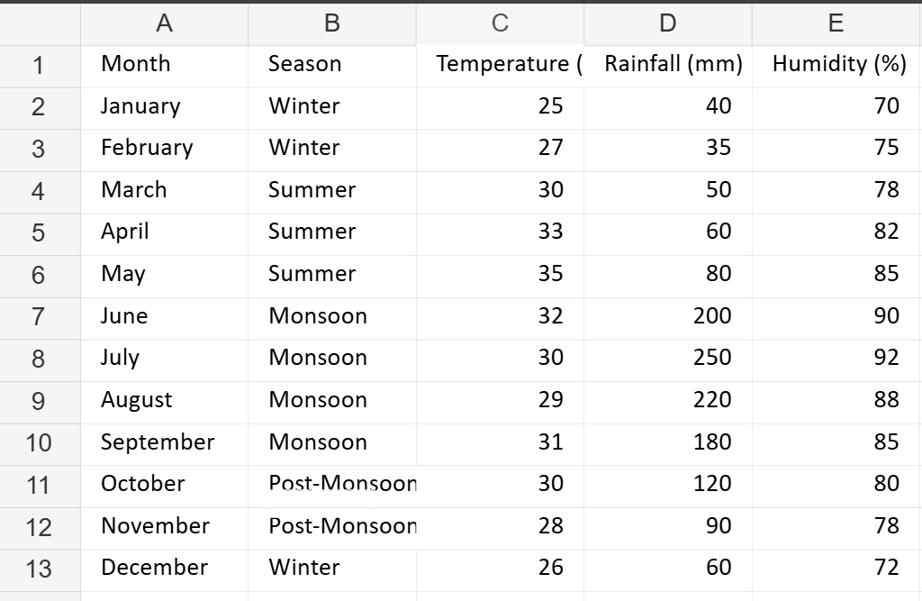

a) Dataset (already in the file)
Columns included:
- Month
- Season
- Temperature (°C)
- Rainfall (mm)
- Humidity (%)

b) Create a Pivot Table (in Excel / LibreOffice Calc)
- Open Climate_Data.xlsx
- Select all the data (Ctrl + A inside the table).
- Go to Insert → Pivot Table
- Choose From Table/Range → OK.
- Place the Pivot Table in a new sheet.

c) Pivot Table Experiments

1. Average Temperature per Month
- Drag Month → Rows
- Drag Temperature (°C) → Values
- Click on Values → Value Field Settings → Average
You will see the average temperature for each month.

2. Total Rainfall for Each Season
- Drag Season → Rows
- Drag Rainfall (mm) → Values
- Set Value Field Settings → Sum
You will get total rainfall for each season.

d) Apply Filters

1. Display data for a specific month
- Drag Month → Filters
- Click the filter dropdown → choose one month (e.g., June)

2. View records where Humidity > 80%
- Drag Humidity (%) → Filters
- Click dropdown → Value Filters → Greater Than → 80
This will show only high-humidity records.

